**Team Project –Team3**

**Requirement Specification**

**of Bekoor6**

Nov. 1. 2019

**Team Members**

|  |  |
| --- | --- |
| **Name** | **Email** |
| Juhyung Kim | kjhkjh75@naver.com |
| Kou Yanran | joy.kou.divg@gmail.com |
| Youngkyoung Kim | agnes66k@naver.com |
| Shenlu Jiang |  |

**Revision History**

|  |  |  |  |
| --- | --- | --- | --- |
| **Version** | **Date** | **Author** | **Revisions** |
| 0.1 | 2019.10.19 | Team3 | Define requirements and User scenarios |
| 0.5 | 2019.10.22 | Team3 | Draw Use-case Diagram |
| 1.0 | 2019.10.31 | Team3 | Finish Entire Section |

**Table of Contents**

1. Introduction 4

1.1. Needs 4

1.2. Bekoor6 5

2. System Architecture 5

2.1. Overall Architecture of Bekoor6 5

2.2. Context of System 6

3. System Functionalities 7

3.1. User Scenarios 7

3.2. Actor Extraction 9

3.3. Use-case Diagram 10

3.4. Function Descriptions 11

3.5. Relationship Among Components 14

4. System Behavior 15

4.1. Purchase Procedure 15

4.2. Live Broadcasting system 15

5. Non-functional Requirements 16

5.1. Quality Attribute Scenarios 16

5.2. Priority of Each Non-Functional Requirements 17

6. System Constraints 18

1. Introduction

This section briefly describes the target system including a description of the technical terms to be used in the future.

* 1. Needs

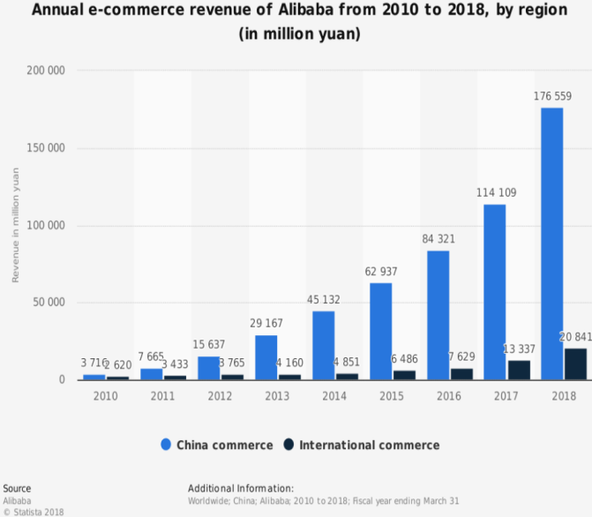Nowadays, online shopping mall is essential for apparel companies. Due to the advance of internet and mobile phone, users prefer to do shopping with mobile application. Mobile shopping mall application provide functions for users convenient shopping. Customers can check details of the product at their home. Also they can pay online so they don’t have to go to the store. This enables users to shop easily and everywhere. Hence more and more users are using mobile application for shopping. As shown in figure2, 259% of users shifted to mobile shopping than using desktop.

Figure 1. Annual e-commerce revenue of Alibaba from 2010 to 2018(in million yuan)

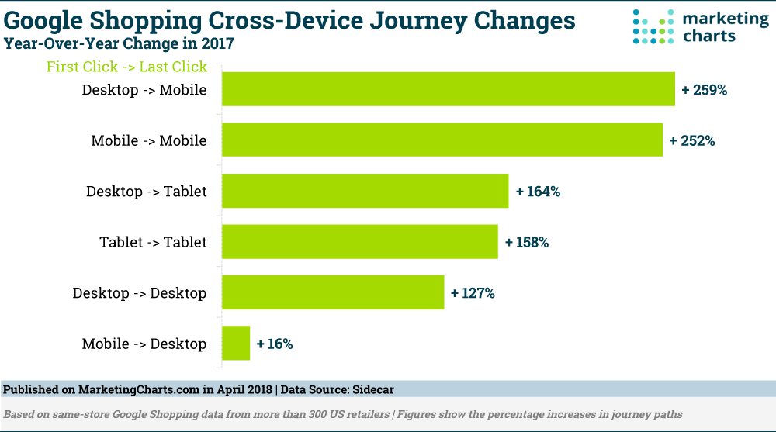

Figure 2.

However there is a need for detailed specification of their product. Due to demand, recent systems apply ‘live streaming’ function to their application. The trend dominates the market in China. In Taobao, the world’s biggest e-commerce website, 81 top live commerce generated more than $15 million in sales. In South Korea, the LF Corp launched live streaming shopping with real0time chatting and one-click purchase. This has resulted in a 30% year-over-year increase since 2015.

* 1. Bekoor6

Bekoor6 is a shopping and live commerce system. In their live video streaming, buyers can interact with and order from sellers in real time. The advantage of live streaming is that they can introduce their products real-time, and give feedback to customers directly. So users may have an immediacy to get the desired product information instantly. The buyer can solve the question of the product by asking the seller about the durability test and the wearing of the clothes. Even after the live streaming is finished, even if the buyer does not watch live while uploading the live video to the seller's store, they can check the product information while watching the uploaded video. The managers can choose the group of the customers for product promotion.

1. System Architecture

This section describes architecture of entire system.

* 1. Overall Architecture of Bekoor6

*Bkoor6 have* two types of server which are ‘Broadcasting Server’ and ‘App Server’. The App Server provides typical functions of online-shop. It manages information of products and payment transactions.

The ‘Broadcasting Server’ is only dedicated for video streams. It is physically separated from the App Server because it needs to handles large sized multi-media. The data can be temporarily cached to proxy servers for providing better user experience.

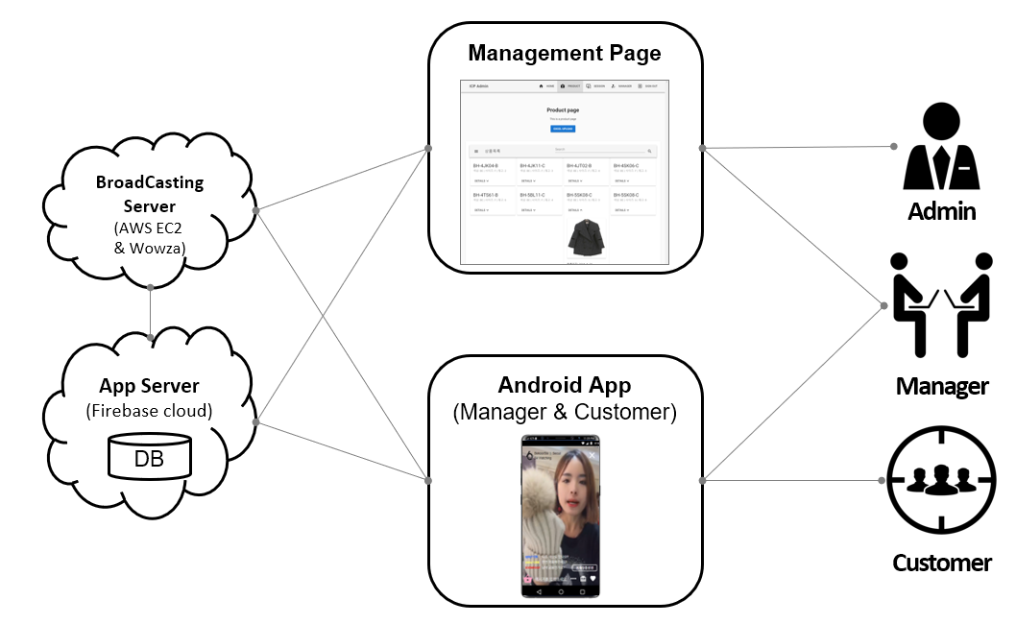Figure 3. System Overview

* 1. Context of System

Internal and external systems which communicate with *Bekoor6* is described in the context diagram and table below.

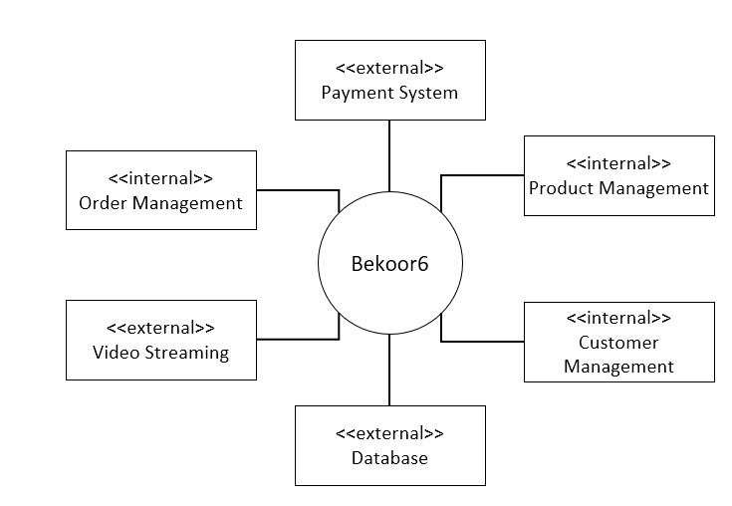

|  |  |
| --- | --- |
| System | Description |
| Payment System | An external system which handles payment transactions |
| Database | An external system which stores every kind of data |
| Video Streaming | An internal system dedicated for managing video streaming service |
| Product Management | An internal system which manages products selling in *Bekoor6* |
| Order Management | An internal system which manages orders and stores history |
| Customer Management | An internal system which manages customers in *Bekoor6* |

1. System Functionalities

This section defines functionalities of the system, where a functionality is described as a specification of behavior between inputs and outputs.

* 1. User Scenarios

1. Bekoor 6 application user scenarios – sign up & log in:

user type 1) customer who watches live video and buys stuff

2) manager (seller) who uploads live video and manages videos and customers

* 1. sign up

- If the user (customer/manager) hasn’t signed up before he/she shall click ‘회원가입’ to start sign up process or click ‘log in with kakao talk ID’ instead.

* + 1. screen switches to sign up form where the user enters must and optional information.
    2. Auth server in Firebase Cloud creates an account with entered information and save this information in DB.
    3. errors show when the user tries to sign up using information not allowed in policies of sign up. (e.g. sign up with existing user name, invalid email address or phone number ect.)
  1. log in
     1. a user can log in with ‘kakao talk ID’ or entering ID & PW information registered in sign up and click ‘로그인’. When clicking ‘log in with kakao’, redirect the user to terms of agreement screen. When clicking ‘log in with Bekoor 6’, a model window shows to choose log in with customer mode or with manager mode.
     2. a user can select ‘auto log in’ and/or ‘save ID’ when log in .
     3. errors show when information with log in is not correct.
     4. if no errors happen main screen of Bekoor 6 will show

1. Bekoor 6 application user scenarios – main screen.

user type: customer

* 1. streaming video thumbnail area

1. a thumbnail of the live video with a ‘LIVE TV’ mark shows in center of the screen if current there is a live video. otherwise, show the thumbnail of the most recent video.
2. a user can check previous broadcasting history list of the seller on right of the video area. when a user clicks one in the list, a thumbnail of the corresponding video shows in the video area.
   1. product list
      1. a list of products showing in the video appear on the bottom of the video. show in clickable thumbnail format.
      2. when a user clicks the thumbnail of a specific product, redirect to the product detail page of the corresponding item.
   2. search area
3. a user can search a specific seller or item by entering the seller’s or item’s name in input box which locates on top of the main screen. a user can also search by clicking the ‘camera’ icon on top and uploading an image to search.
   1. bottom button area

a user can go to home screen, check profile info and favorites of managers in main screen.

* 1. manager list

All managers show in the main screen. When a user clicks one, he/she can check detailed information of the manager and subscribe the manager’s channel.

1. Bekoor 6 application user scenarios – LIVE STREAMING screen.

user type: customer

* 1. a user enters the LIVE streaming screen when clicking the thumbnail of a live video in main screen.
  2. A user can also enter the LIVE streaming screen when getting a invitation of the manager.
  3. a user can chat while watching the live video.
  4. A user can share the broadcasting to other social media.

1. Bekoor 6 application user scenarios – main screen.

User type: manager

* 1. after log in, four menus show in main screen: new broadcasting, product management, profile info, log out.

1. Bekoor 6 application user scenarios – add new broadcasting.

User type: manager

* 1. when clicking ‘new broadcasting’ menu on main screen, a list screen of products shows with a search box on the top and the list below.
  2. A user can select one or multi products to add to his/her broadcasting.
  3. A user can invite different groups of users to watch his/her broadcasting and it is possible for him/her to manage(edit) these groups when needed.
  4. A user can generate a new broadcasting (video) and upload this to Bekoor 6 broadcasting server.

1. Bekoor 6 application user scenarios - product management.

User type: manager

* 1. a user can check each product detail information like item name and the corresponding remaining amount .

1. Bekoor 6 application user scenarios – purchase page.

User type: customer

* 1. The name, grade, options as well as transport information of the product can be confirmed obviously.
  2. customer can double check the product details, evaluations, transport payment information and seller warranty information through the purchase page.
  3. The transaction history will be listed in the most recent order and the related products will be shown as well.
     1. If customer puts the product in shopping cart, he/she can check it out in the shopping cart.
     2. If customer makes purchase immediately, the express information and payment can be performed clearly

1. web page management scenarios.

User type: manager & admin

* 1. sign up & log in
     1. a user must sign up and log in before using web management functionalities.
  2. Product management
     1. a user can check full list (all products) in product management page.
     2. A user can search specific product
     3. A user can check detail information of a product when selecting it in the list.
     4. A user can set a product to be closed (판매종결). And a user can check all products which are closed(판매종결).
     5. A user can upload new products. Support excel. (it is possible to upload an excel file with new products’ information). And after uploading this kind of information will be saved to server.
  3. Session (broadcasting) management
     1. a user can check full list (all sessions).
     2. A user can check detail information like manager info, start time and public or not in the session list.
     3. A user can edit detail information of a specific session (edit public or not, start time etc.).
  4. Manager (authority) management
     1. a user can check full list (all members of a session).
     2. A user can check detail information of a member after clicking.
     3. A user can edit the role of a member in detail information window. (set to be admin or manager or unset admin or manager)
  5. Actor Extraction

The actors got extracted from user scenarios as below table.

|  |  |
| --- | --- |
| Actor | Description |
| Customer | A user of system who purchases products. |
| manager | A user of system who sells products, uploads videos and manages products and customers. |
| admin | A super user who manages managers. |
| Payment System | An external system which handles payment. |

* 1. Use-case Diagram

The following use-case diagrams show the whole functionality of the target system. It is specified with including actors, use-cases and their relationships.

* Watch / browse live channels

* Order products

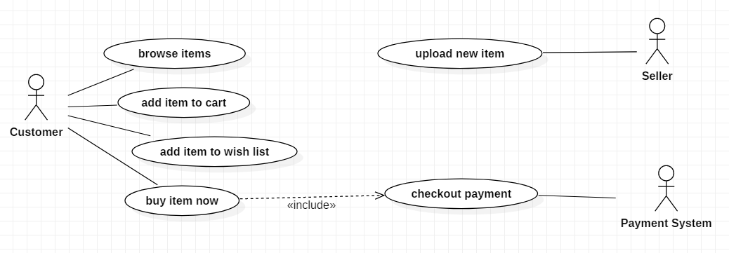

* 1. Function Descriptions

|  |  |
| --- | --- |
| Function name | 1. **Sign up** |
| Definition | Customer can register own account for using application. |
| Input | Write the customer`s information to join membership. |
| Output | Customer can get the profile and member number. |
| Process | In main screen click the menu icon and the click the setting and write the own information. |
| Conditions | customer should have phone number and certificate it. |

|  |  |
| --- | --- |
| Function name | 1. **Login** |
| Definition | Customer can login using own id and password |
| Input | Write the ID(email)and password |
| Output | Customer can use membership`s function. |
| Process | Write the Id and Password and correct the written information with stored data in database. |
| Conditions | database should have all member`s information to correct the member data |

|  |  |
| --- | --- |
| Function name | 1. **Open live stream channel** |
| Definition | Manager can open live channel to show the live streaming. They can promote their item`s through streaming. |
| Input | Manager create the live channel and start the streaming to show items. |
| Output | Live streaming displayed on screen. |
| Process | Login ID that authorized as manager and start the live streaming then streaming will show the manager`s screen. |
| Conditions | member who get the authorized as manager only use the this function. |
|  |  |

|  |  |
| --- | --- |
| Function name | 1. **Watch live streaming** |
| Definition | Customer can choose the streaming which he or she want to see , and watch manager`s live streaming promotion. |
| Input | If there are live streaming, customer just click the join stream. |
| Output | Customer can watch the live streaming. |
| Process | Anyone who has the ID can easily watch the streaming , just choose the stream and click. |
| Conditions | To watch the live streaming, customer must sign up the application. |

|  |  |
| --- | --- |
| Function name | 1. **Watch video that stored** |
| Definition | Customer can watch the video that stored in advance. |
| Input | If there are videos related with items, just click the videos. |
| Output | Videos which is stored displayed on screen. |
| Process | Anyone who has the ID can easily watch the videos related with items, if click the videos with items. |
| Conditions | Application must have stored videos related with items. |

|  |  |
| --- | --- |
| Function name | 1. **Live chat** |
| Definition | Customer or manager can write the message and show message to other`s in real time |
| Input | Just chat what they want to tell others |
| Output | Every people join the streaming can see the chat which is written by customers or manager. |
| Process | If people join the stream, they write the their opinion to chat line and displayed on other`s display. |
| Conditions |  |

|  |  |
| --- | --- |
| Function name | 1. **Favorite channel** |
| Definition | Customers can add the channel in favorite menu then you can get several notification |
| Input | Customer clicks favorite button which shape is heart. |
| Output | Customer will be receiving shop's upcoming activities and deals. |
| Process | Login to the website and open the store and click follow button. Customer will be added to the store members DB and will be receiving updates on store. |
| Conditions | Customer should be logged in. In other words, guest users are not allowed to favorite the channel |

|  |  |
| --- | --- |
| Function name | 1. **Browse channel** |
| Definition | Customer should be allowed to browse currently open or incoming channels |
| Input | Customer search the channel in main page |
| Output | Recent channel list should be shown related with items. |
| Process | First in main page, search the items, and choose the channel from list |
| Conditions |  |

|  |  |
| --- | --- |
| Function name | 1. **Share the items through SNS** |
| Definition | Customer can share the information about items which he or she like to their friends through SNS like kakao,facebook. |
| Input | In item pages, click the share and choose the what sns you want to send |
| Output | Item information sent to friends who customer choose |
| Process | When customer click share and choose sns and friends, item`s information will be sent to friends who customer choose. |
| Conditions | Customer`s account should be linked with sns account. |

|  |  |
| --- | --- |
| Function name | 1. **Share the items through SNS** |
| Definition | Customer can share the information about items which he or she like to their friends through SNS like kakao,facebook. |
| Input | In item pages, click the share and choose the what sns you want to send |
| Output | Item information sent to friends who customer choose |
| Process | When customer click share and choose sns and friends, item`s information will be sent to friends who customer choose. |
| Conditions | Customer`s account should be linked with sns account. |

|  |  |
| --- | --- |
| Function name | 1. **Add item to cart** |
| Definition | Customer can add products to shopping cart from product detail information page. |
| Input | Click the “Add to Cart” button. |
| Output | Customer can store own favorite item list. |
| Process | Click “Add to Cart” from the page and customer reaches to shopping cart page. |
| Conditions | Customer should login so that use the cart. |

|  |  |
| --- | --- |
| Function name | 1. **Buy item** |
| Definition | Customer can buy products immediately from product detail information page. |
| Input | Click the Buy Now button. |
| Output | Customer reaches to order page. |
| Process | Click the “Buy Now” from the page and customer reaches to order page. |
| Conditions | Customer should be in product detail page. |

|  |  |
| --- | --- |
| Function name | 1. **Notice** |
| Definition | Admin upload notice for all customers. |
| Input | Admin write the notice |
| Output | Created notice for all customer |
| Process | Click the “notice” icon so Admin can write the information and upload.  Then all customer can see the information which Admin upload. |
| Conditions | Only Admin can write the letter so most user can`t do this. |

* 1. Relationship Among Components

Streaming component

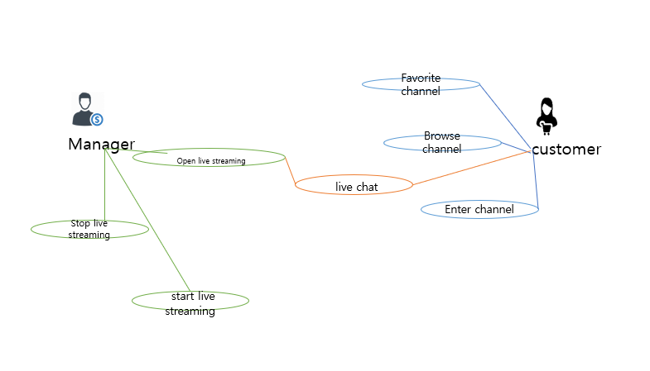

Item Component

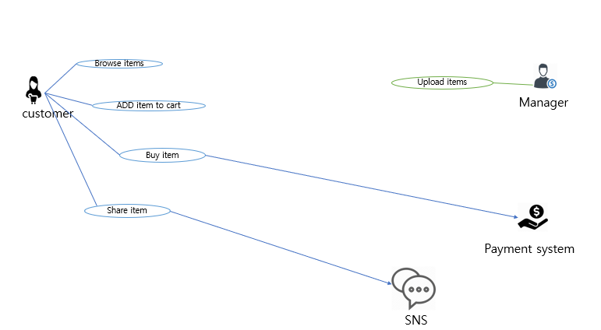

1. System Behavior
   1. Purchase Procedure

Payment is important function because it is directly affect to customer’s money. So payment procedure should be handled safely and it should be able to be rejected when the payment system notifies it was failed.

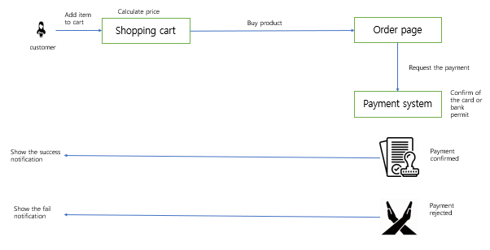

* 1. Live Broadcasting system

Broadcasting is most important procedure in this application . so Broadcasting system several behavior.

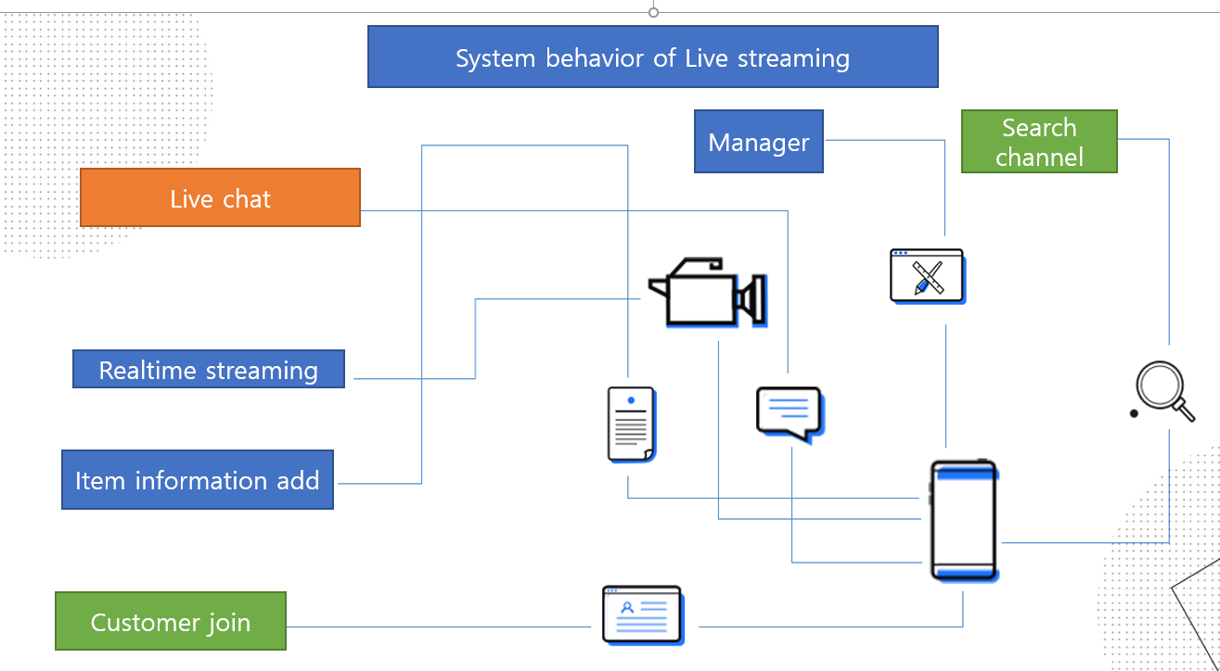

1. Non-functional Requirements

This section specifies criteria that can be used to judge the operation of a system, rather than specific behaviors. They are contrasted with functional requirements that define specific behavior or functions.

* 1. Quality Attribute Scenarios

|  |  |
| --- | --- |
| **Security** | |
| Source | Individual or system that is not identified or unknown identity |
| Stimulus | Attempts to access user information or payment information |
| Artifact | Data within system |
| Environment | System is online |
| Response | Hides identity of the user except identified user’s own information |
| Response Measure | Probability of detecting attack. |

|  |  |
| --- | --- |
| **Performance** | |
| Source | Users |
| Stimulus | Requests for video streaming |
| Artifact | System |
| Environment | Under normal/overload mode |
| Response | Returns video stream |
| Response Measure | Latency and throughput |

|  |  |
| --- | --- |
| **Safety** | |
| Source | Users |
| Stimulus | Requests for payment |
| Artifact | System |
| Environment | Payment system is online or offline |
| Response | Proceeds the payment or rollback when it is not available |
| Response Measure | Probability of incorrect payment |

|  |  |
| --- | --- |
| **Usability** | |
| Source | Users |
| Stimulus | Tries to connect to system with PC or mobile devices. |
| Artifact | System |
| Environment | At runtime |
| Response | Shows different GUI for each devices |
| Response Measure | User satisfaction |

* 1. Priority of Each Non-Functional Requirements

Utility tree is derived from quality attribute scenarios considering an implementation risk and business importance.

1. System Constraints
2. Technical constraints
   1. The system should support streaming on all kind of Android mobiles.
   2. The system should support payment on all kind of Android mobiles.
3. Business constrains
   1. The system should be ready to demo until August 2020
   2. The system should spend less than 1 billion dollars.